June 16, 2025

First Name Last Name
Chapter Name
Address
City, State, Zip

Dear [First Name]:

SMACNA remains committed to the longevity, stability and prosperity of the sheet metal and air conditioning industry. Through initiatives like education, training, events and the development of cutting-edge technical standards, SMACNA continues to support our industry’s advancement.

To ensure the continued success of these initiatives, SMACNA adopted a scheduled contribution rate increase in 2023. This change has been communicated to Chapter Executives through multiple channels, including an email sent on March 14, 2023, collective bargaining orientation, Council of Chapter Representatives meetings, and various other SMACNA events and publications.

This plan introduces a one cent ($0.01) per hour increase every three years, beginning January 1, 2026.

- Effective January 1, 2026: Contribution increases from $0.15 to $0.16 per hour (for hours worked after December 31, 2025)

- Effective January 1, 2029: Contribution increases from $0.16 to $0.17 per hour

- Effective 2032, 2035: Every three years thereafter

This predictable schedule helps support long-term planning and sustained investment in the industry’s future.

Please contact me or Linda Jennings if you have any questions.

Sincerely,
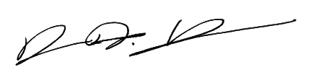
Aaron Hilger
CEO

